QR code

A Project Report Submitted
for

Information Technology
By

Lucky kholiya
(Roll no. 15)

Under the guidance of
Mr. Praveen Kumar Joshi



EVER GREEN SENIOR SECONDARY SCHOOL
(GOVERNED BY EDUCATIONAL WELFARE SOCIETY)
TULARAMPUR - 223139, DISTRICT-NAINITAL
UTTARAKHAND, INDIA

OCTOBER, 2021

CERTIFICATE

This is to certify that the project entitled “QR code” being submitted to Evergeen Senior Secondary School, Haldwani for the project work of INFORMATION TECHNOLOGY is a record of the work carried by MR. Lucky kholiya under my guidance and supervision.

Date: Supervisor
MR. PRAVEENJOSHI
TGT Computer
Ever Green Sr. Sec. School, Haldwani
Forwarded By:
MR. M.S. PARWAL
Principal
Ever Green Sr. Sec. School, Haldwani

Abstract
QR code means Quick Response .
QR code is a 2D matrix code that is designed by keeping two points under consideration , i.e it must store large amount of data as compared to 1D barcodes and it must be decoded at high speed using any handheld device like phones . QR code provides high data storage capacity , for , Omnidirectional readability and many other advantages including error correction and different types of version . Different varieties of QR codes symbols like logo QR code , encrypted QR code , iQR code are also available so that user can choose among them according to their needs . Now these days a QR code is applied in different application streams related to marketing , security , academic etc. and gain popularity at a really high pace . Day by day more people are getting aware of this technology and use it accordingly . The popularity of QR code grows rapidly with the growth of smartphones user and has the QR code is rapidly arriving at high levels of acceptance worldwide .

ACKNOWLEDGEMENTS
I would like to express my most sincere heartfelt gratitude and respect to my supervisor MR. PRAVEEN JOSHI, for suggesting the topic for my project work and for his excellent guidance, valuable suggestions and endless support throughout for preparing the report. I am greatly indebted to him for his constructive suggestions and criticism from time to time during the course of progress of my work.
I would like to express my gratitude and sincere thanks to Mr. M.S. Parwal, Principal of School, and entire faculty who has imparted considerable knowledge to me.
Finally, I express my deepest gratitude to my parents for their continuous encouragement, understanding and support.

(Lucky kholiya)

TABLE OF CONTENTS

Chapter | Topic | Page No.
 | CERTIFICATE
 | ACKNOWLEDGEMENT
 | LIST OF FIGURES
 | ABSTRACT
1. | INTRODUCTION | 6-7
1.1 | QR code | 6
1.2 | Invention of QR code | 7
1.3 | QR code definition and Meaning | 7
2. | How do QR codes work? | 7
3. | Uses of QR code | 9-10
3.1 | How do QR code payment work? | 9
3.1.1 | How to scan QR code? | 10
4. | How do QR codes work? | 11-12
4.1 | Parts of a QR code? | 11
4.2 | What can QR codes do for you? | 11
4.3 | What is the initial purpose of QR codes ? | 12
4.4 | Design of QR code. | 12
5. | History of QR code | 12
6. | Adoption of QR code | 12-14

LIST OF FIGURES

S.No. | Name | Page No.
1. | QR code | 7
2. | How do QR code | 8
3. | How do QR code payment work | 9
4.
5.
6.
7.

1 Introduction
  - QR code
The full form of QR codes is quick response code. It is invented in 1994 by the Japanese automotive company Dense Wave. A QR code is a type of barcode that can be read easily by a digital device and which stores information as a series of pixels in a square-shaped grid . A barcode is a machine readable optical label that contains information about the item to which it is attached.
The quick response system became popular outside the automotive industry due to its fast readability and greater storage capacity compared to standard UPC barcodes .
A QR code consists of black squares arranged in a square grid on a white background which can be read by an imaging device such as a camera and processed the using read-solomon error correction until the image can be appropriately interpreted. The required data is then extracted from patterns that are present in both horizontal and vertical components of the image.

Fig.1.1 : QR code
  - Invention of QR code
The first QR code system was invented in 1994 by the Japanese company Denso Wave , a Toyota subsidiary . They needed a more accurate way to track vehicles and parts during the manufacturing process . To achieve this they developed a type of barcode that could encode kanji, kana and alphanumeric characters .
  - QR code definition and Meaning
QR stands for quick response .
While they may look simple QR codes are capable for storing lots of data . But no matter how much they contain , when scanned , the QR code should allow the user to access information . Hence, why it's called a Quick Response code.
2. How do QR codes work ?
A QR code might looks like a random mix of scribbles and black and white squares , but each slice contains several layers of information . When anyone can it with the help of compatible app , all of that information gets to put together in the right order for the code to be read.
The square marking in The scholars of a QR code tell the orientation of the code. This means customers can scan the code from any angle without worrying that it will be read backward .
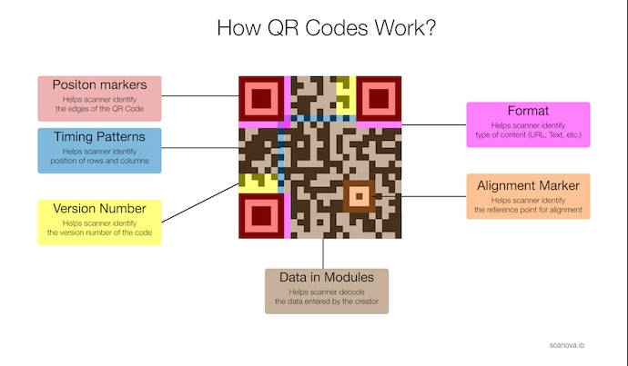
QR codes have a space surrounding the square . It is called the quiet zone and it's there to help the smartphone app recognize where the code stops .
Fig.1.2 : How do QR codes work?
3. Uses of QR code?
- To download an app on the Apple app store or Google Play .
- Verify login details.
- Send and receive payment information .
- Access Wi-Fi by storing encryption detail such as SSID , password and encryption type .
Etc . are the uses of QR code .
3.1 How do QR code payment work?
- Get your QR code:- On the web, click get your QR code , then , login into your PayPal account and download your QR code . You can also create your QR code using the PayPal Business app.
- Display your QR code:- Print your code and hang a copy wherever a customer can easily scan it during the checkout process , like on your register or counter .
- Shoppers scan the QR code .
- Receive your payment .
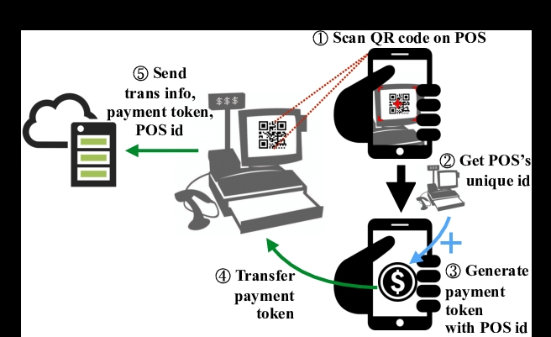
Their payment appears in your PayPal account and the transaction is complete .
Fig.1.3 : how do QR code payment work
3.1.1 How to scan QR code?
Most smart phones have built-in QR scanners , which are sometimes built in the camera . A QR scanner is a simply a way to scan QR codes .
Some tablets, such as the Apple iPad , have QR readers build into their cameras .
Some older devices may require a particular app to read QR code – these apps readily available on the Apple app store and Google Play .
Scanning QR code using your device is straight forward:-
- Open the QR reader application for the camera on your smartphone.
- Point it at the QR code - you should be able to point your camera from any angle and still receive the necessary information .
- The data will be instantly shown on .
4 How do QR codes work ?
The patterns within QR code represent binary code that can be interpreted to reveal the code’s data .
A QR reader identify a standard QR code based on the three square outside the QR code. Once it has identified these three shapes , it knows that everything contained inside the square is a QR code .
The QR reader then analyses the QR code by breaking the whole thing down to a grid . It looks at the individual grid squares and assigns each one a value based on whether it is black or white . It then groups grid squares to create larger patterns .
4.1 Parts of a QR code?
Standard QR code is identifiable based on six components:-
1 . Quit zone – This is the empty white border around the outside of a QR code.
2. Finder pattern – QR codes usually contain three black squares in the bottom left, top left, and top right corners .
3. Alignment pattern – This is another smaller square contained somewhere near the bottom right corner .
4. Timing pattern – This is an L-shaped line that runs between the three squares in the finder pattern .
5. Version Information – This is a small field of information contained near the top right finder pattern cell . This identify which version of the QR code is being read .
6. Data cells – The rest of QR code communicates the actual information , i.e., the URL , phone number, or message it contains .
4.2 What can QR code do for you ?
Plenty in terms of optimizing your marketing campaign with QR codes, you have the flexibility of adding more content , in different formats , without compromising the design of your packaging , disrupting your brand identity , overloading your audience with text or overspending on printing .
4.3 What is the initial purpose of QR codes ?
QR codes were originally invented to replace barcodes at supermarkets as they can store more information and are easier to scan . Now , QR codes have a wide range of uses across all types of industries such as in education, marketing and logistics .
4.4 Design of QR code .
Unlike the older , one – dimensional barcodes that were designed to be mechanically scanned by a narrow beam of light, QR code is detected by a two-dimensional digital image sensor and then digitally analyzed by a programmed processor . The processor located the three distinctive squares at the corners of the QR code image, using a smaller square (or multiple square ) near the fourth corner to normalize the image for size, Orientation and angle of viewing . The small dots around the QR code are then converted to binary numbers and validated with an error correcting algorithm .
5 History of QR code
The QR code system was invented in 1994 by Masahiro Hara from the Japanese company Denso Wave . The initial design was influenced by the black and white pieces on a Go board . Its purpose was to track vehicles during manufacturing; it was designed to allow High-speed component scanning . QR codes are now used in a much broader context , including both commercial tracking applications and convenience – oriented applications aimed at mobile-phone user . QR codes may be used to display text to the user, to open a webpage on the user’s device , to add a VCard contact to the user’s device , to open a Uniform Resource Identifier (URI) , to connect to a wireless network , or to compose an email or text message . There are a great many QR codes generated available as software or as online tools that are either , or require a paid subscription . The QR code has become one of the most used types of two-dimensional code .
6. Adoption of QR code
During the month of June 2011 , 14million American mobile users scanned a the QR code or a barcode. Some 58% of those users scanned a QR and barcode from their homes ,while 39% persons can from retail store 53 % of the 14 million users were men between the ages of 18 and 34 .
A September 2020 survey found that 18.8 percent of consumers in the United States and United Kingdom strongly agreed that they had noticed an increase of QR code used since the beginning of covid-19 related shelter -in- place orders in March 2020 .
6.1 Risks in QR code
The only context in which common QR code scan carry executable data is the URL data type. These URLs main host JavaScript code, which can be used to exploit vulnerabilities in applications on the host system, such as the reader , the web browser or the image viewer, since a reader will typically send the data type used by the QR code .
In the case of no software exploits, malicious QR codes combined with a permissive reader can still put a computer’s can contents and users privacy at risk . This practice is known as “attagging” , a portmanteau of “attack tagging” . They are easily created and can be affixed over legitimate QR codes . On a smartphone , the reader’s permissions may allow use of the camera , full internet access, read/write contact data , GPS and read browser history , read/ write local storage and global system changes .
Risks include linking to dangerous websites with browser exploits, enabling the microphone/camera/GPS and then streaming those fields to a remote server , analyses of sensitive data, and sending email/SMS/IM messages or DDOS packets as a part of botnet , corrupting privacy settings, stealing identity , and even containing malicious logic themselves such as JavaScript or a virus . These actions would occur in the background was the user is only seeing the reader opening a seemingly harmless webpage . In Russia, a malicious QR code cost phones that scanned it to send payment text at a fee of US$6 each .
6.2 Why do we use QR code
We use QR code because it was:-
- Faster - once you created a QR code , you can start taking payment immediately .
- More efficient – QR code scan hold much more data than barcodes .
- More secure – QR codes are difficult to enter or hack .
- More reliable – because QR codes are read in multiple directions, they can still be recognized by a scanner , even is the QR code itself is damage or partially torn .
Thank you
Submitted by :- Submitted to:-
Lucky kholiya. Mr. Praveen Joshi
Class – 9 C
R.no – 15

